**Note: Have changed all. Please give your feedback.**

**Check for equipment page: In this page, if you want to navigate particular page, we can override software back button but in this case we cannot target particular page using arrow button in xamarin forms. So I have removed arrow button. So you can use your mobile back button to get particular page.**

1.

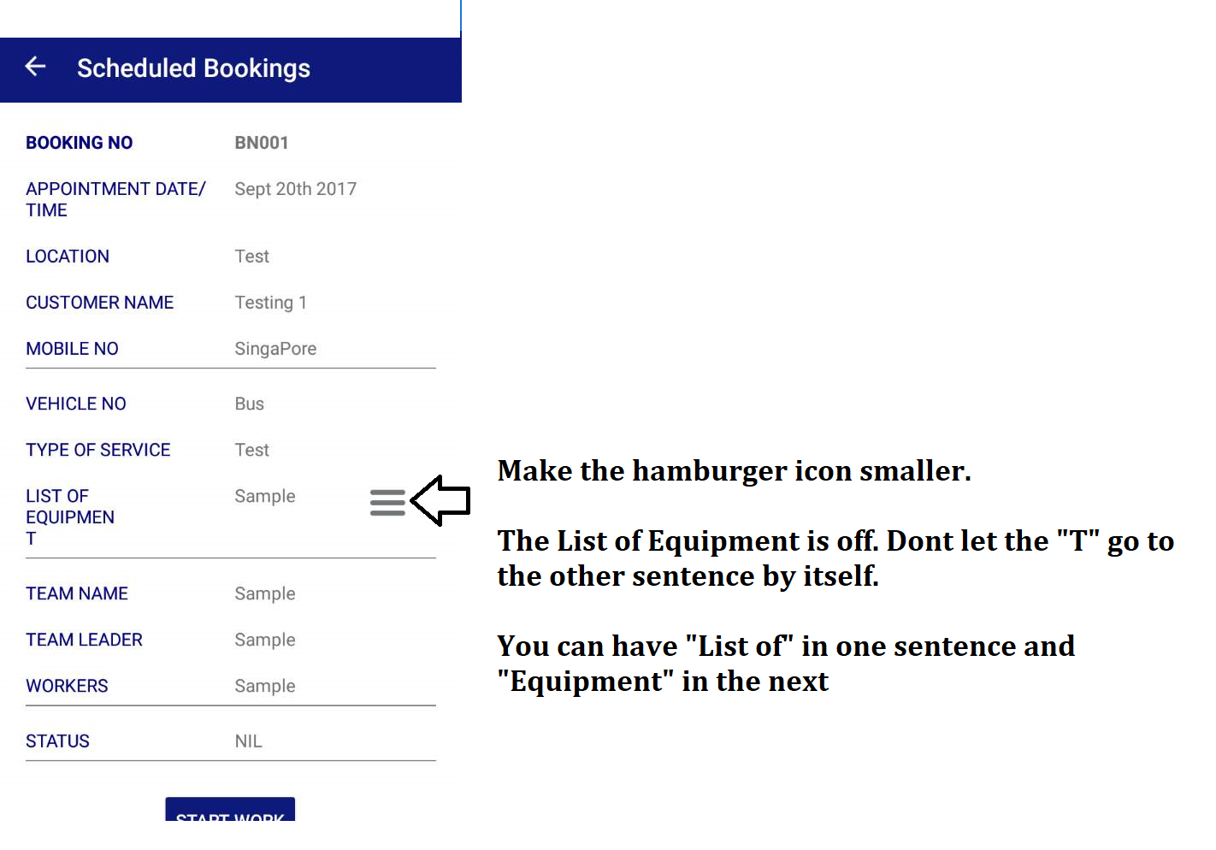

2. 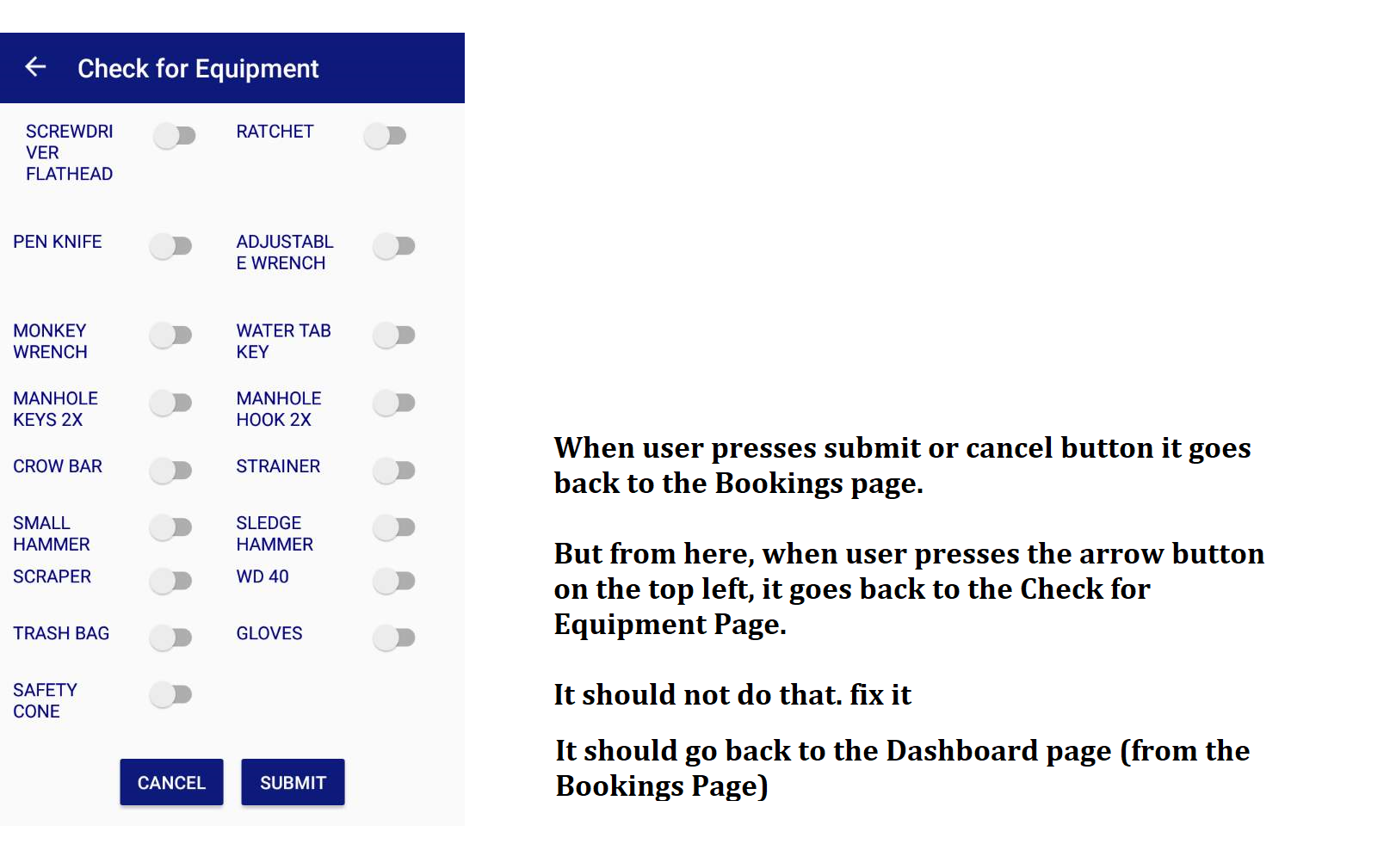

3.

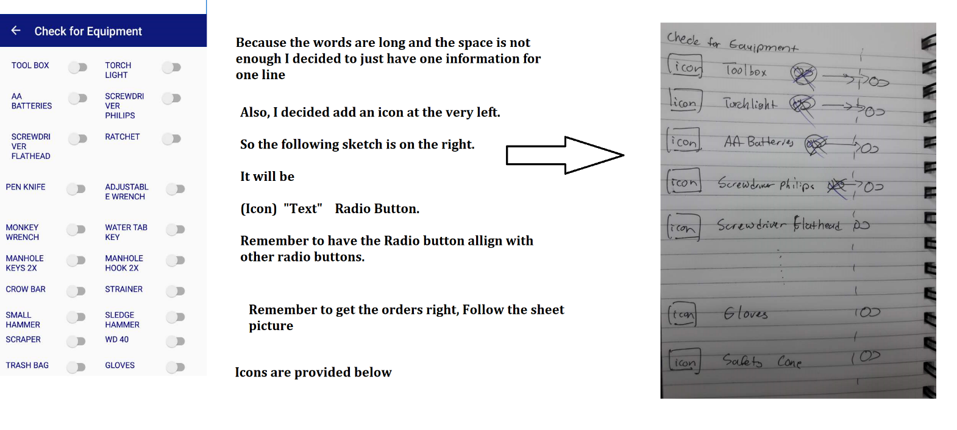

I will give you the icons Folder